**Chapter 1**

**Introduction and Overview of the Project.**

* Introduction.
* Problem Statement.
* Objectives and Goals.
* Scope of the Project.
* Importance of the Project.
* Tools needed for the project.
* Approach selected in Development.
* Project development team.
* Critical Assumptions made.
* A Gantt chart – Timeline Visualization.

1. **Introduction**

DurusApp - a name coined from *Durus* (Arabic for Lessons) and *App* (Application) – describes a system designed to serve a religious purpose of delivering Islamic Lectures from different mosques on mobile handsets. This report focus on the mobile Application aspect of its implementation. DurusApp is thus a platform where lecturers or scholars from across different mosques, post their content regarding the lessons they offer and generally their weekly schedule while on the other hand, Students access these information on the specifics of Lectures, and participate in them at their convenience.

In this chapter, we thus aim to explain what generally triggered the idea behind the project. We will explain how the problem is rooted in two distinct audiences that the application targets. These opens the path to define its scope – the audience and geographical context of the project. We then present the predetermined goals for the project and how the problems we outlined, define these goals. Having used contrapositive, counter arguments and contradicting our goals as our main technique to extract importance from our objectives, we present how these project proves to be significant to our current societal setting.

We will then lightly touch on our internal arrangement as a team. What do we exactly need to implement DurusApp? The development paradigm we settled on, and how are we split the project into sub tasks needed accomplish the main mission. The nature of the project sometimes calls for an environmental setting that might have been inexistent or necessitates immediate resources that were unavailable at our disposal. What were these uncertainties? Finally we present a visual representation of this subtasks with their estimated execution periods.

1. **Problem Statement**

While we have enough Universities and lots of religious content on the internet, the gap of Islamic Illiteracy grows bigger and bigger. As Muslims, and the world in general, imbibe more from social Media platforms, they equally detach from Knowledge and their spiritual guidance. The problem of Islamic illiteracy is too general. Narrowing the problem down to two distinct groups, we find a more fundamental problem.

1. **The problem with the Students of Knowledge.**

As students come to seek Knowledge in Sudan and Most Islamic countries, they do so with no prior exposure to Islamic Knowledge setting. As such, a student might need to follow the guidelines laid down by a scholars.

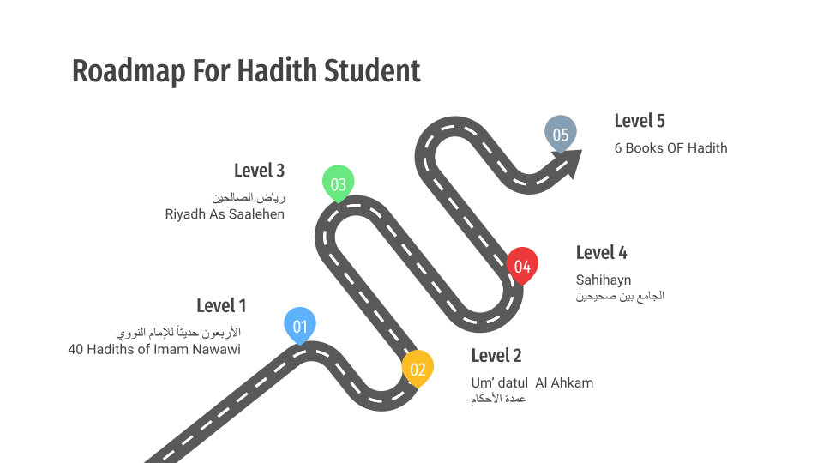

Fig 1. A Sample Hadith Roadmap

The info graph above shows a typical roadmap. The real challenge happens to be in the following questions

1. Who will guide the student where and when to attend this lessons of books in different lectures?
2. It rarely happens that a scholar will teach all the books in a row, but at any time given, at least a mosque is teaching one of these books. How will this transition happen and result into a smooth the search of Knowledge?
3. **The problem in the Islamic household.**

Muslims, like other societies are facing a challenge in curbing the drastic changes in their households. A child grows up with multiple sources of information. These, as pointed out earlier, takes from these households with the same extent they give to other sources like social media platforms, movies, cartoons and friends. At the same time, even the slight urge of Study is satisfied and suppressed by the audio and video clips they stumble upon on these platforms. A wide spread of Ignorance and anomie is apparent. As such, Islamic knowledge ought to be presented as early and often to these households: organized and well presented, exclusively meant to be a complete learning and teaching tool for guardians.

1. **Objectives and Goals.**

From the above presented problems, we can define our objectives as follows

* Create a mobile application that seeks to collect all the details of all the different Courses going on in Khartoum Mosques sorted into categories and scholars, without merging it up with any other form of Application or social media platforms.
* Register and keep track of all the lessons recorded in DurusApp for access by later students.
* Have a personalized communication between a Scholar and Students following their lectures, whether following from home or physical appearance.
* Notify and inform users of the Application of all sorts of details about the lectures or scholars they follow.
* Provide users with roadmaps by different scholar as curriculums to be used by new students in searching of knowledge. These curriculums can be used by students to decide their journeys before starting in specific fields.
* Lastly, we aim to initiate an open source project on GitHub, after a later release to collaborate with developers on this project until we see it grow with a community that will support and share it with.

1. **Importance of the project**

* The platform will help students realize the large community of scholars at their disposal. The will help in planning their steps when seeking knowledge especially with the roadmaps.
* Students will request and get updates or notifications on the courses they follow. These will help them know when new content has been added on a new lesson. Scholars will also have a glimpse of their knowledge circles.
* The application will also separate the Islamic Knowledge setting from other socials. These will help solve the fundamental problem of a false satisfaction on Islamic Knowledge and channel the urge to seek knowledge into its correct channel.
* The creation of an open source project today is a trigger to a call to all experienced Muslim developers and stakeholders to sponsor and maintain the project. If DurusApp grows within the Islamic community, it will be a useful tool in rejuvenating the Islamic culture and principles once again within the Islamic Society.
* DurusApp in its essence, is an electronic learning school in its own. The applications extreme flexibility will surely invite in new modules like Fatwa, Question and Answers, Student Chat Rooms, memorization Modules and live coverage of lessons. In fact, this is our final destiny if Allah wishes.

1. **Tools needed for the Project**

DurusApp was developed in an intense environment with our project tools changing from phase to phase.

**Persistent** software tools throughout the project included:

* Git and GitHub for *version Controls*
* Android Studio for *Android development*
* Adobe XD for *Designs and Wire Framing*
* Visual Studio Code for *Laravel Development.*
* Postman Inc. for API *documentation and testing*.
* Cpanel – for a Sever Hosting UI control
* Google Play Console – A web application to manage built apps

**Intermittent** software tools included:

* Visual Paradigm and Microsoft Visio design tooling
* Xampp – Apache based local server, for testing before API deployment

We hardly used new **hardware** tools other than Laptops and Android running phones.

1. **Approach selected in Project Development**

From API construction to the Application and Web Development, we used an iterative and incremental method in building our system. On each iteration, we ensure that a particular logic works perfectly fine, before picking on other logic. This however was only applicable to development and design. The same would not apply for the Database design which was done once and implemented as a final output.

1. **Project Development Teams.**

Based on the nature of the project, we had the to break the tasks into the following

* Database Design team.
* Back End development team
* Designers for the Adobe XD sketches
* Front End team – for the Web Admin
* Front End Team – for the Android Applications
* A community of testers. (Google being a platform providing such service).

1. **Critical Assumptions Made**

DurusApp was developed with some degree of uncertainty. The uncertainties pose a level of threat in their appearance, but more importantly will prove as points of improvement from the team’s side as well as future stakeholders.

* That an alternative will be found for Google’s Cloud Push Notifications and Amazon Web Services Notifications. The two are, at the time of development blocked in this area.
* Get a fast and cheap server for API deployment.

1. **Gantt Chart**

